1. EERD:



I wrote down the cardinality ratios and entity relationships and participations below so that way the ERD did not become too convoluted.

Cardinality:

* patient table:
  + One patient can have one or many health records (1:N).
  + One patient can be associated with one or many invoices (1:N).
  + One patient can be hospitalized in only one room (1:1).
  + One patient can be monitored by one or many physicians (1:N).
  + One patient can receive instructions from one or many physicians (1:N).
  + One patient can have one or many executed orders (1:N).
  + One patient can be administered one or many medications (1:N).
* physician table:
  + One physician can monitor one or many patients (1:N).
  + One physician can provide instructions for one or many patients (1:N).
* nurse table:
  + One nurse can execute one or many orders (1:N).
  + One nurse can administer one or many medications (1:N).
* room table:
  + One room can accommodate only 1 patient (1:1).
* medication table:
  + One medication can be administered to zero or many patients (1:N).
* instruction table:
  + One instruction can be provided to one patient (1:1).
* invoice table:
  + One invoice is associated with one patient (1:1).
  + One invoice is associated with one instruction (1:1).
  + One invoice is associated with one room (1:1).
* payment table:
  + One payment is associated with one patient (1:1).
  + One payment is associated with one invoice (1:1).
* healthRecord table:
  + One health record is associated with one patient (1:1).
* patientHospitalized table:
  + One patient can be hospitalized in one room (1:1).
* physicianMonitors table:
  + One physician can monitor multiple patients (1:N).
* physicianInstructs table:
  + One physician can provide instructions to multiple patients (1:N).
  + One instruction can be associated with multiple medications (1:N).
* executesOrder table:
  + One nurse can execute an order for multiple patients (1:N).
  + One order is associated with one patient (1:1).
  + One order is associated with one instruction (1:1).
* administerMedicine table:
  + One nurse can administer multiple medications to one patient (N:1).
  + Multiple medications can be administered to one patient (N:1).

Entity relationships/participation

* patient entity:
  + Total participation in the healthRecord relationship (1:1).
  + Total participation in the invoice relationship (1:1).
  + Total participation in the patientHospitalized relationship (1:1).
  + Partial participation in the physicianMonitors relationship (1:N).
  + Partial participation in the physicianInstructs relationship (1:N).
  + Partial participation in the executesOrder relationship (1:N).
  + Partial participation in the administerMedicine relationship (1:N).
* physician entity:
  + Partial participation in the physicianMonitors relationship (1:N).
  + Partial participation in the physicianInstructs relationship (1:N).
* nurse entity:
  + Partial participation in the executesOrder relationship (1:N).
  + Partial participation in the administerMedicine relationship (1:N).
* room entity:
  + Partial participation in the patientHospitalized relationship (1:1).
* medication entity:
  + Partial participation in the physicianInstructs relationship (1:N).
  + Partial participation in the administerMedicine relationship (1:N).
* instruction entity:
  + Partial participation in the physicianInstructs relationship (1:N).
  + Partial participation in the invoice relationship (1:N).
* invoice entity:
  + Total participation in the patient relationship (1:1).
  + Total participation in the instruction relationship (1:1).
  + Total participation in the room relationship (1:1).
* payment entity:
  + Total participation in the patient relationship (1:1).
  + Total participation in the invoice relationship (1:1).
* healthRecord entity:
  + Total participation in the patient relationship (1:1).
* patientHospitalized entity:
  + Total participation in the patient relationship (1:1).
  + Total participation in the room relationship (1:1).
* physicianMonitors entity:
  + Total participation in the physician relationship (1:1).
  + Total participation in the patient relationship (1:1).
* physicianInstructs entity:
  + Total participation in the physician relationship (1:1).
  + Total participation in the instruction relationship (1:1).
  + Total participation in the medication relationship (1:1).
  + Total participation in the patient relationship (1:1).
* executesOrder entity:
  + Total participation in the nurse relationship (1:1).
  + Total participation in the patient relationship (1:1).
  + Total participation in the instruction relationship (1:1).
* administerMedicine entity:
  + Total participation in the nurse relationship (1:1).
  + Total participation in the medication relationship (1:1).
  + Total participation in the patient relationship (1:1)

1. Assumptions:
   1. Hospital Room Capacity: I assumed most hospital rooms to contain 1 patient, so I treated this field moreso as a flag. For example, if the room is vacant, capacity is set to ‘Y’
   2. It is assumed that multiple nurses and physicians can treat multiple patients. It is also assumed that patients can receive more than one medication.
   3. 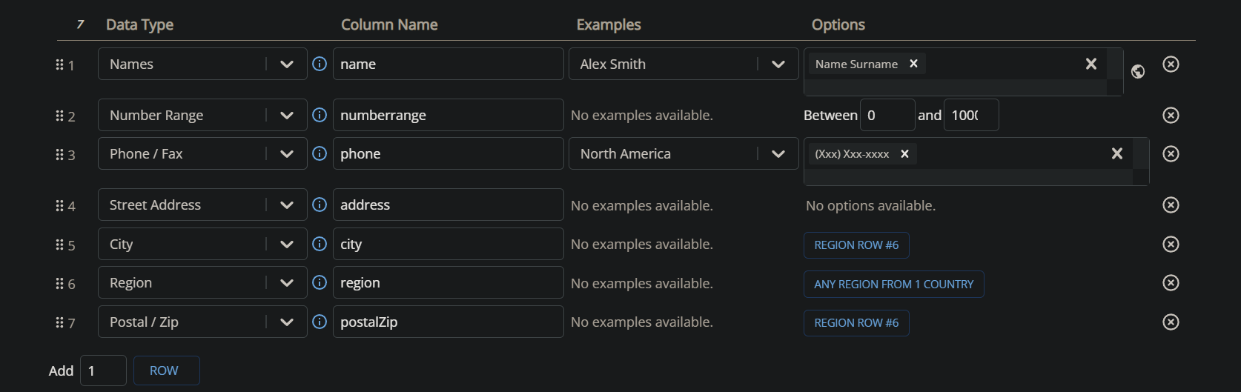I used a website to generate some of the basic data for the patients, physicians, and nurses. Example:
   4. I tied the duration that physician monitors the patient to the number of nights the patient has been hospitalized. For example, if the patient has been hospitalized for 3 nights, and the physician started monitoring the patient by the second night, then the physician has monitored the patient for 2 nights.
   5. Medication amounts are measured in ccs.
2. Relations and keys:
   1. Relation Patient(Patient_id, patient_name, phone_number, street_address, city, state, zip)
      1. primary key: {Patient_ID}
   2. Relation healthRecord(Record_id, Patient_ID, Disease, record_Date, record_status, record_desc)
      1. primary key: {Record_ID}
      2. Foreign key: {Patient_ID references Patient(Patient_ID)}
   3. Relation Physician(Physician_ID, physician_name, Certification_Number, physician_field, Phone_number, street_address, city, state, zip)
      1. primary key: {Physician_ID}
   4. Relation Nurse(Nurse_ID, nurse_name, Certification_number, Phone_number, street_address, city, state, zip)
      1. primary key: {Nurse_ID}
   5. Relation Room(Room_id, Capacity, room_fee)
      1. primary key: {Room_id}
   6. Relation patientHospitalized(Patient_ID, Room_id, Nights)
      1. primary key: {Patient_ID, Room_id}
      2. foreign key: {Patient_ID references Patient(Patient_ID), Room_id references Room(Room_id)}
   7. Relation physicianMonitors(Physician_ID, Patient_ID, Duration)
      1. primary key: {Physician_ID, Patient_ID}
      2. foreign key: {Physician_ID references Physician(Physician_ID), Patient_ID references Patient(Patient_ID)}
   8. Relation Instruction(Instruction_id, instruction_Fee, instruction_desc)
      1. primary key: {Instruction_id}
   9. Relation phsyicianInstructs(physician_id, instruction_id, medication_id, patient_id)
      1. Primary key: {physician_id, instruction_id}
      2. Foreign key: {physician_id references Physician(physician_id), instruction_id references Instruction(instruction_id), medication_id references Medication(medication_id), patient_id references Patient(patient_id)}
   10. Relation executesOrder(Nurse_ID, Patient_ID, Instruction_id, execute_Date, order_Status)
       1. primary key: {Nurse_ID, Patient_ID, Instruction_id}
       2. foreign key: {Nurse_ID references Nurse(Nurse_ID), Patient_ID references Patient(Patient_ID), Instruction_id references Instruction(Instruction_id)}
   11. Relation Medication(Medication_ID, Medication_name, medication_amt)
       1. primary key: {Medication_ID}
   12. Relation administersMedicine(nurse_ID, Medication_ID, patient_id)
       1. primary key: {Physician_ID, Medication_ID,patient_id}
       2. foreign key: {Physician_ID references Physician(Physician_ID), Medication_ID references Medication(Medication_ID), Patient_id references Patient(patient_id)}
   13. Relation Payment(Payment_ID, Patient_ID, payment_Date, payment_Amt)
       1. primary key: {Payment_ID}
       2. foreign key: {Patient_ID references Patient(Patient_ID)}
   14. Relation Invoice(invoice_id, invoice_date, invoice_amt, patient_id, instruction_id, room_id)
       1. Primary key: {invoice_id}
       2. Foreign key: {patient_id references patient(patient_id), instruction_id references Instruction(instruction_id), room_id references Room(room_id)}
3. Views and descriptions
   1. This view shows the breakdown of each patient's invoice

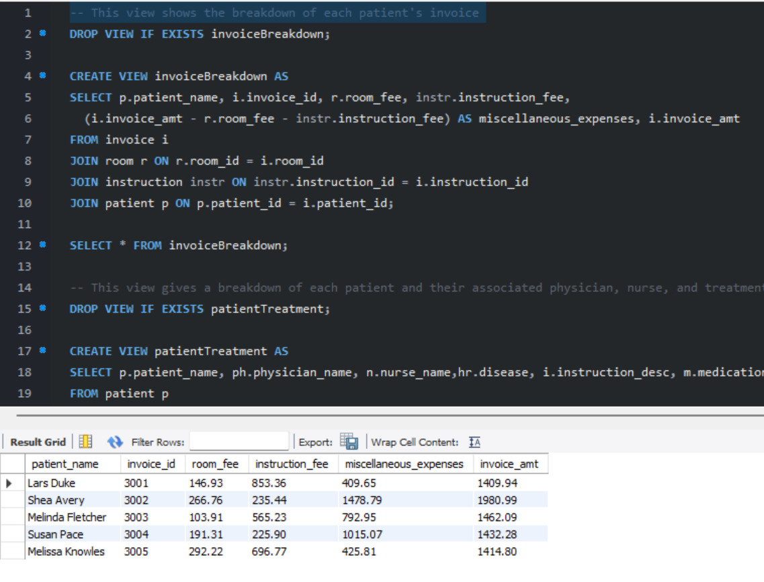

* 1. This view gives a breakdown of each patient and their associated physician, nurse, and treatment plan, as well as the current status.

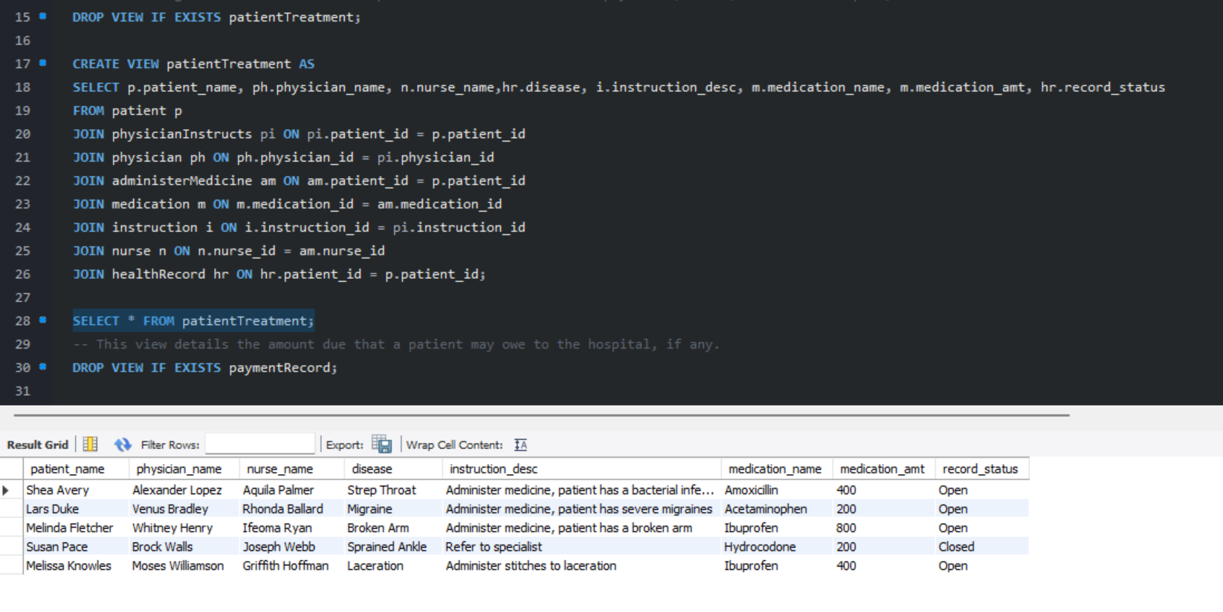

* 1. This view details the amount due that a patient may owe to the hospital, if any.

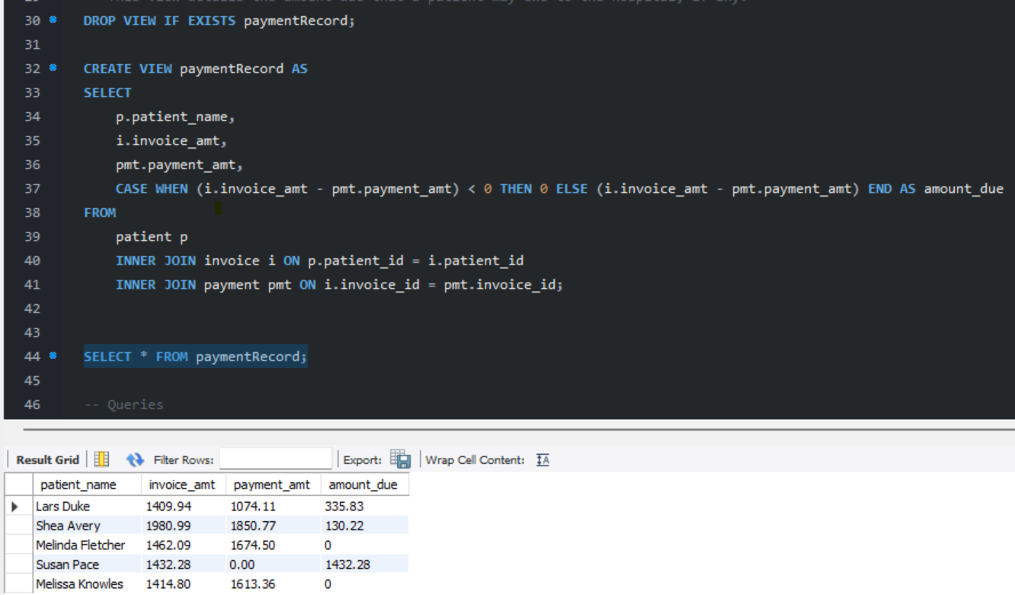

1. Queries, descriptions, and results
   1. Query to find which rooms are occupied and who occupies that room.

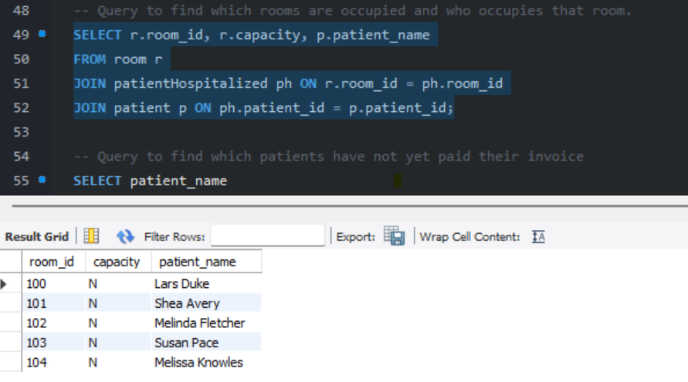

* 1. Query to find which patients have not yet paid their invoice

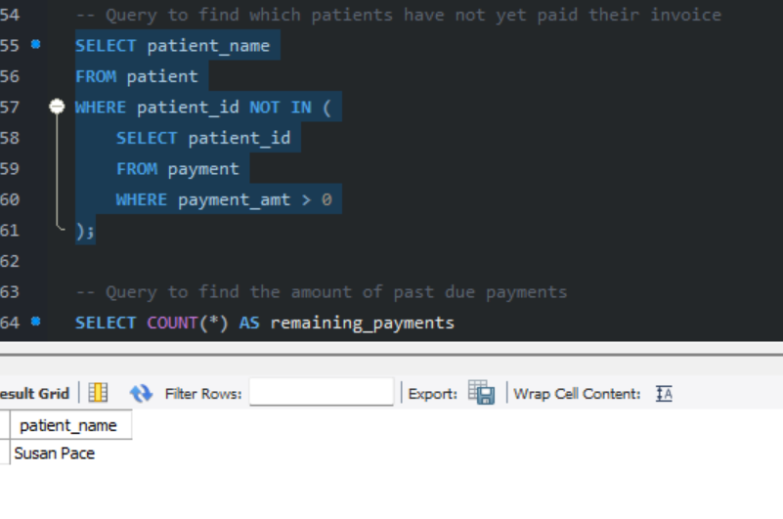

* 1. Query to find the amount of past due payments

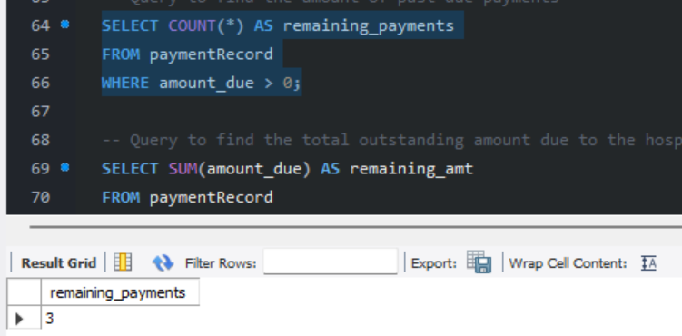

* 1. Query to find the total outstanding amount due to the hospital



* 1. Query that shows which room each nurse treats each patient in

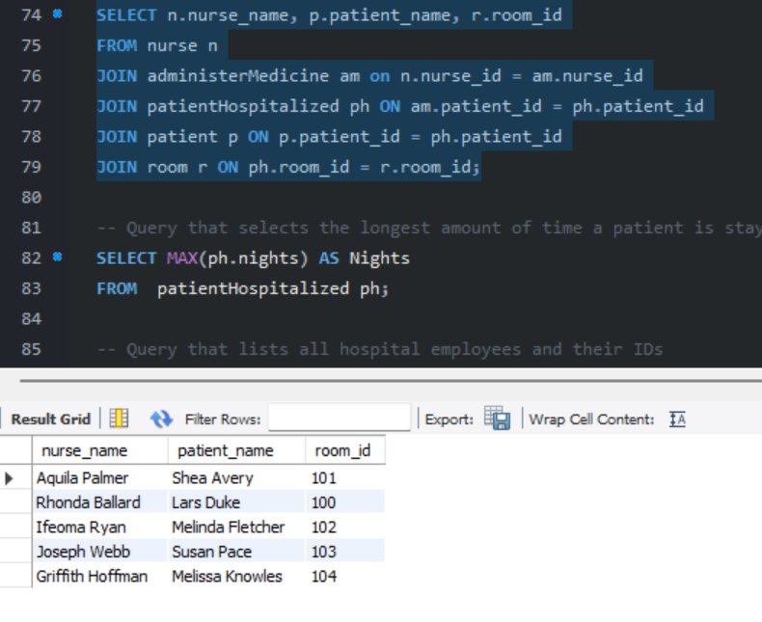

* 1. Query that selects the longest amount of time a patient is staying at the hospital.

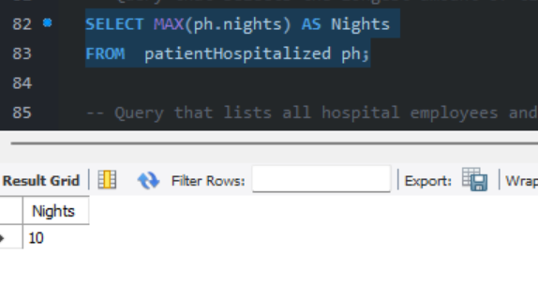

* 1. Query that lists all hospital employees and their IDs

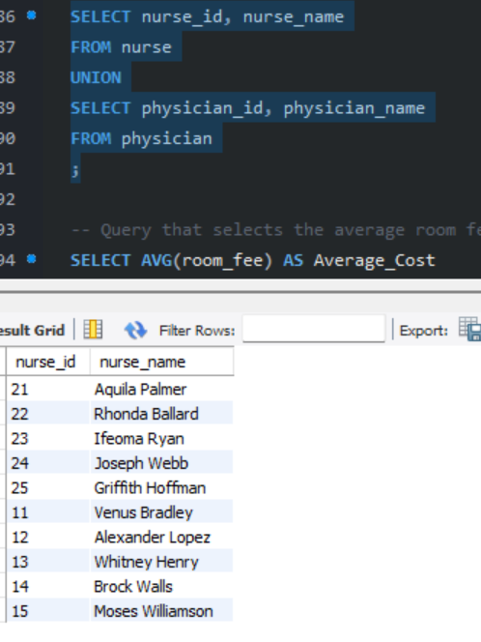

* 1. Query that selects the average room fee in the hospital

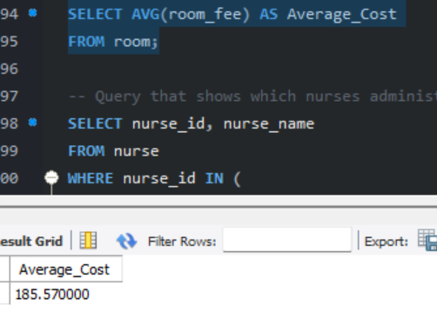

* 1. Query that shows which nurses administer Hydrocodone

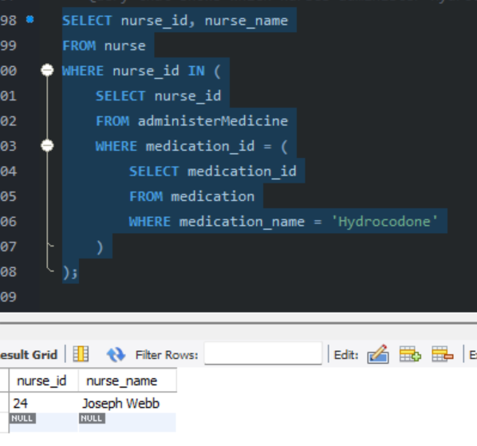

* 1. Query that shows how long each physician has been monitoring each patient

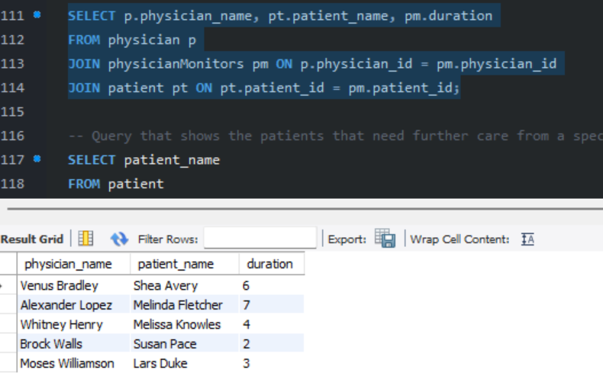

* 1. Query that shows the patients that need further care from a specialist

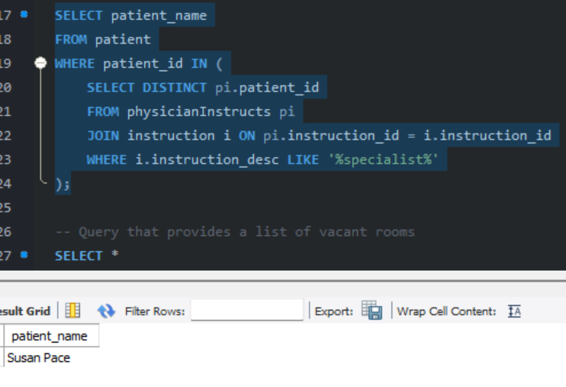

* 1. Query that provides a list of vacant rooms

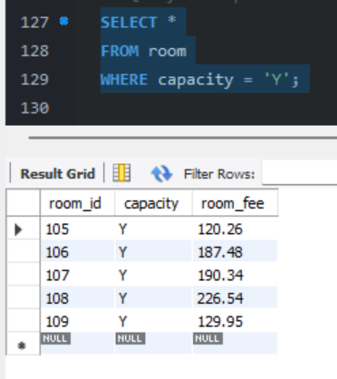

* 1. Query that provides a list of patients that are instructed to be administered medicine by

a physician

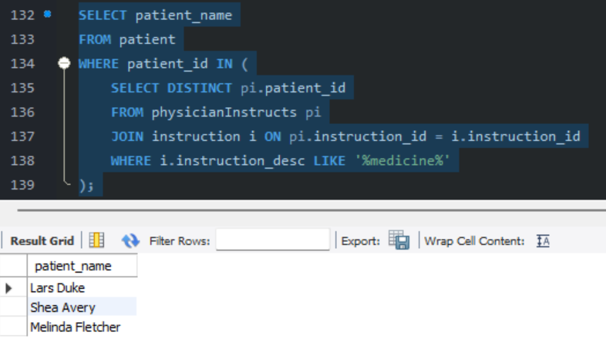

* 1. Query that shows when each patient began treatment

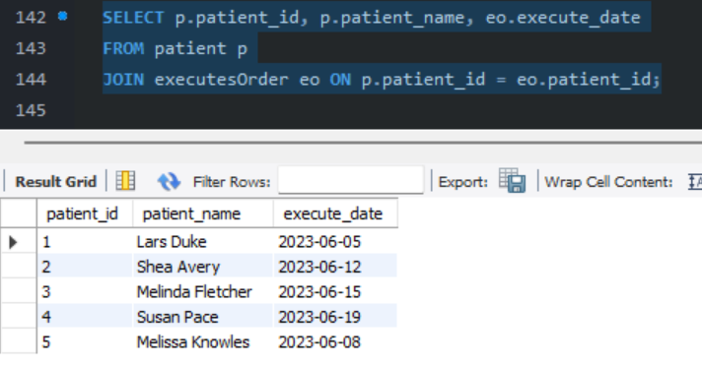

* 1. Query that shows patients that need continued treatment

